From Isolation to Adaptation
______________________________
The times, they are a-changin’. Now that we’ve seen Japan through its years of isolation, we move on to a different theme: adaptation. Japan is learning to adapt to the new world and we are going along for the ride. After you have completed the tasks below, you will surely be a master of all things Japanese.
 Stage One
Objective 6: What were the motivations for the radical changes in Japan’s model of organization during the Meiji period?
Objective 7: How did Japan adapt to changes brought on by the transition from feudal to modern models of organization?
- Complete a note web for pages 333-342.
- Complete a cause and effect chart using pages 333-342.
- Create a set of point form notes using pages 333-342.
- Complete a T-chart to record the factors that motivated Japan to end it’s isolation.
Objective 8: How did the changes resulting from adaptation affect Japan economically, politically and socially during the Meiji period?
Objective 9: What challenges emerged for the Japanese in maintaining traditional cultural aspects of their society while undergoing rapid change?

- Complete a web that explores the causes and effects of change within Japan.
- Create a set of point form notes that highlight the changes that took place in economy, politics and society. Include your thoughts on challenges that may rise when trying to maintain the distinct culture as changes took place.

Objective 10: In what ways did changes resulting from isolation in the Edo period compare to changes resulting from adaptation in the Meiji period?
- Complete a Venn diagram that highlights the changes during Isolation to the changes during adaptation.
- Complete a change chart that compares Edo Period to changes after the Meiji period.
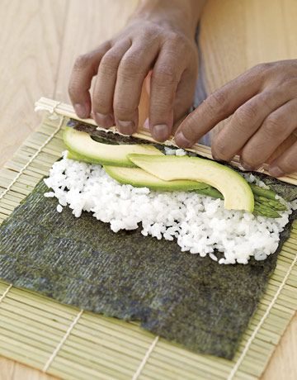 Stage Two
- Write a series of journal entries from a variety of perspectives that would have witnessed the changes taking place in Japan. Address the questions on your procedure sheet and consider how their different viewpoints would affect their attitudes towards the changes.
- Create a graphic novel that has three separate storylines. Create a brief storyline that would include characters affected by political changes, a storyline with characters affected by social changes, and a storyline with characters affected by economic changes. Think of it as three sub-plots in one TV show. Consider very carefully which groups you will be
- Create the “Ballad of Westernization” for Japan. Ballads are longer songs or poems that tell a story. Turn Japan’s progress into a story that you’ll express lyrically. Whether you choose a song or poem is up to you, but be detailed!
- Create a museum that focuses on the changes that Japan has gone through. Choose objects that represent Japan before contact, and changes that affected Japan after contact. As a museum curator, you want to make sure that you include a write up so that museum spectators follow your vision.
- Marvel Comics was so impressed by the creative influx of Japanese heroes that they have submitted a new request. Due to all of the changes in Japan, your old hero no longer fits the mould of Japanese Worldview. To reflect the changing times, create another Japanese hero that reflects worldview after contact with the outside world.

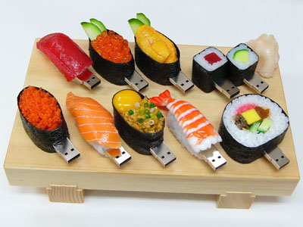 Stage Three
Globalization: to extend to other or all parts of the globe; make worldwide
The advantages and disadvantages of globalization have been debated and scrutinized heavily in recent years. Proponents of globalization say that it helps developing nations "catch up" to industrialized nations much faster through increased employment and technological advances. Critics of globalization say that it weakens national sovereignty and allows rich nations to ship domestic jobs overseas where labor is much cheaper.
- With the rapid growth of the internet and other technologies, the world has gone global! Individual worldviews are at stake, and cultures, traditions, and other things that make us unique are at risk! In response to all of this technology and the sure-fire globalization, Canadians are at risk of losing their identity through contact and change, just like how Japan was forced to change theirs! Should Canada adopt a foreign policy of isolationism or a policy of adaptive response?
- Globalization is something that each country in the world has to be aware of. There are positive and negative impacts on the effects of globalization. Where should we go from here? What does Japan’s experience tell us about the way intercultural contact affects a culture’s sense of identity?

